We obtain battle fatalities numbers from the ACLED dataset and yearly air traffic, FDI, and GDP data from the World Bank, regressing on a subset of countries for which we had full data (N=846).

We ran a difference-in-difference model with the following specification:

lm(ln_FDI ~ ln_battle_fatalities +

ln_GDP + ln_battle_fatalities * treatment + post_treatment)

Regressing the log+1 of total FDI on the log+1 of battle fatalities, log+1 of GDP, the interaction between log+1 of battle fatalities and the treatment variable (coded as “1” for any year after the largest percentage increase in a country's air traffic, given it at least doubles), and the post-treatment variable (the number of years after the first treatment year).

This yielded significant results for the interaction term at the 1% level, showing that while controlling for battle fatalities and GDP, a country’s FDI is positively associated with a spike of air traffic when interacting with battle fatalities. This interaction term has a positive beta while battle fatalities has a negative beta on its own, showing ______. A spike of air traffic does not have a significant relationship with FDI on its own in this model.

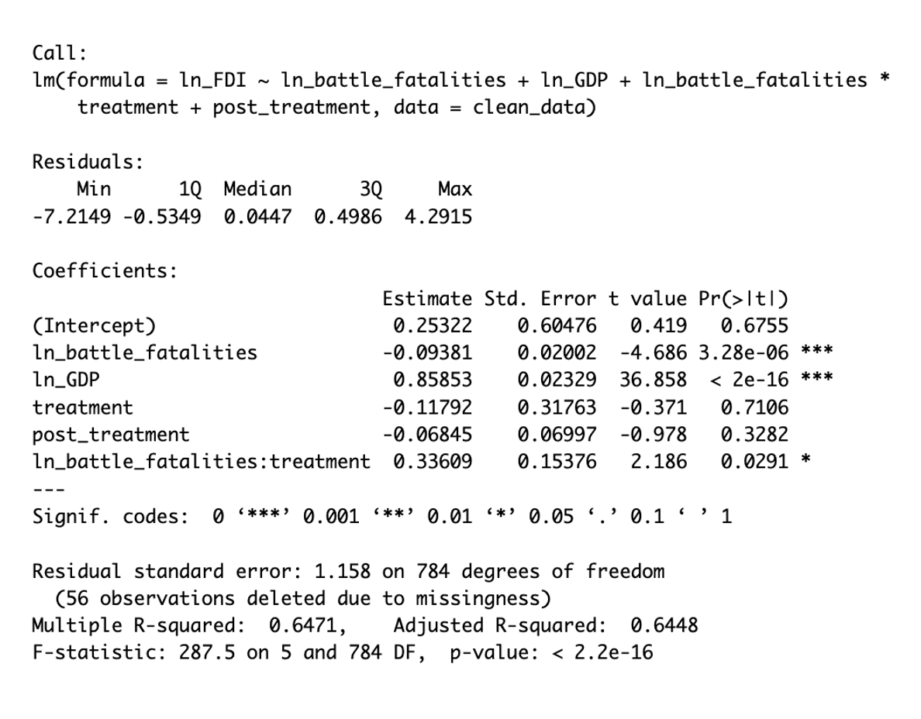

However, if one removes the post-treatment variable, there is a positive relationship between just the treatment (coded as “1” for any year after the largest percentage increase in a country's air traffic, given it at least doubles) and log+1 of total FDI, significant at the 5% level.

